Annexure-I
Invention Disclosure Form - Product (Utility Patent)

Continued…

- Title of the Proposal
Title of the Patent : ResQ-MAR: An AI-Powered Autonomous Multi-Agent System for Multimodal Emergency Response and Offline Geospatial Routing.

Domain of the Idea : Artificial Intelligence (AI), Disaster Management Technology, Geospatial Routing, and Edge Computing.
- Details of the Inventor(s)
Give the following details of all the Inventors
Inventors:
Name: M N V Satya Sai Ram Dinkar Reg. No: 23BCE9130 Role: Primary Contact Inventor / Student
Name: Sachin Vishwakarma Reg. No: 23BCE9150 Role: Inventor / Student
Name: R Ganesh Reg. No: 23BCE20205 Role: Inventor / Student
Name: M Gowtham Sai Reg. No: 23BCE20092 Role: Inventor / Student
Co-Inventor:
Name: Prof. K. Siva Kumar Role: Co-Inventor / Faculty Guide
Notes:
- Indicate the Primary Contact Inventor from the above list of inventors for queries and information exchange

- Student initiated invention shall include at least one Faculty as Co-Inventor

- Abstract / Description of the Proposed Idea

Abstract:
The present invention relates to an autonomous emergency response system utilizing a Multi-Agent System (MAS) architecture to process disaster reports and dynamically route rescue vehicles. The system, termed ResQ-MAR, utilizes an 8-agent AI swarm (powered by Microsoft AutoGen) to ingest multimodal emergency data (text, audio via Whisper, images via Gemini Vision). To prevent AI hallucinations and ensure legal compliance, it utilizes Agentic Retrieval-Augmented Generation (RAG) referencing a local ChromaDB vector database of official NDMA protocols. Uniquely, the system calculates physical rescue routes entirely offline using a local Open Source Routing Machine (OSRM) and mathematically translates final dispatch instructions into regional languages based on GPS coordinates. The system achieves an end-to-end emergency resolution latency of just 4.1 seconds.

Description of the proposed Idea:
The invention solves the bottleneck of human-operated emergency dispatch during mass-casualty disasters by replacing it with a fully autonomous AI swarm.
- Intake & Structuring: Panicked multimodal inputs are ingested and structured into strict JSON metadata (Severity, Coordinates) by Intake and Metadata agents.
- Context & RAG Verification: A LiveAwareness agent scrapes real-time internet conditions while a Planner Agent consults local government SOPs (NDMA guidelines) via ChromaDB to draft rescue strategies.
- Geospatial & Hazard Logic: Using the shapely library, the system calculates if the emergency falls within known geographical hazard polygons (e.g., Coastal Cyclones, Seismic zones).
- Offline Routing: A Router Agent interfaces with a local Docker-containerized OSRM map engine to calculate exact road-following routes (in ~45ms) and actively calculates detours if roadblocks are simulated.
- Localization: A Comms Agent utilizes a geo-coordinate heuristic to determine the Indian State of the emergency, automatically translating the final alert into English, Hindi, and the local regional language (e.g., Tamil, Marathi) for drivers.
Problem Statement:
During major natural disasters (cyclones, floods), traditional 911/112 emergency dispatch centers become overwhelmed, leading to high response latencies and human cognitive overload. Furthermore, existing AI solutions proposed in recent literature suffer from three major flaws: (1) They rely on single-LLM architectures which are prone to severe hallucinations; (2) They are entirely dependent on Cloud APIs (like Google Maps or OpenAI) which fail completely when a disaster destroys local internet infrastructure; (3) They only classify the emergency but fail to execute physical, mathematical vehicle routing.

Scope for our work:
· Commercialization / Industry Domain: B2G (Business-to-Government), Smart City Infrastructure, Healthcare & Ambulance Fleet Management (Govt. 108 Services), and Defense/Military triage.
· Scalability: Capable of pan-India deployment. The local-LLM (Ollama) and local-OSRM architecture allows the system to scale infinitely without incurring pay-per-token API costs.

- Circuit Diagrams / Photos / Flowcharts / Statistic Tables (whichever is applicable)
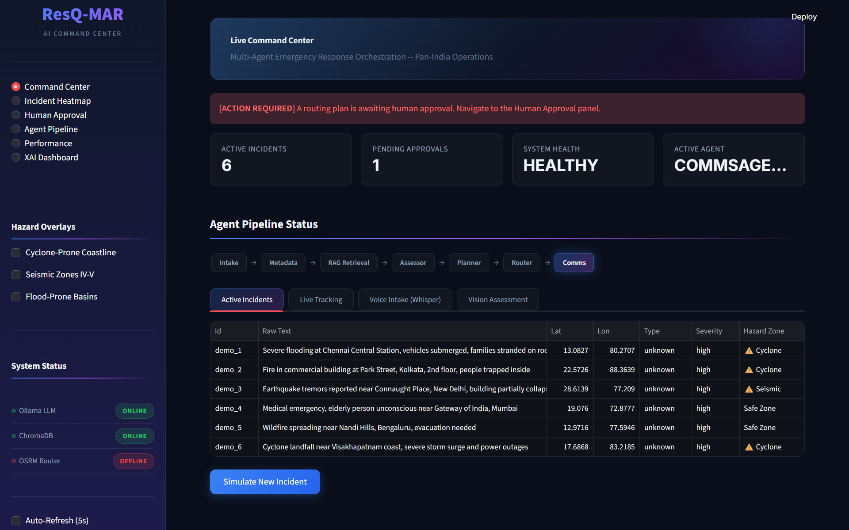
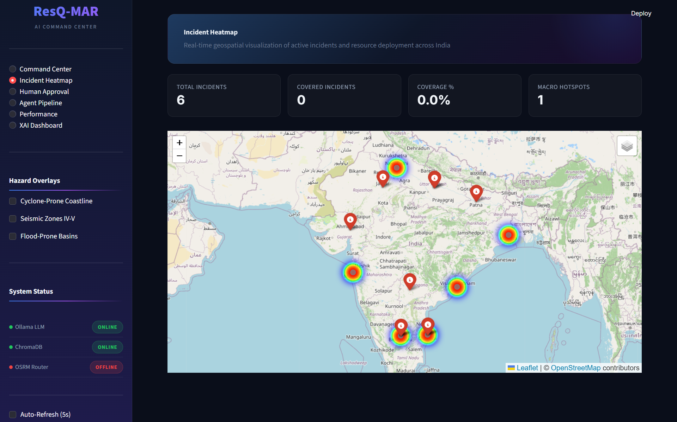
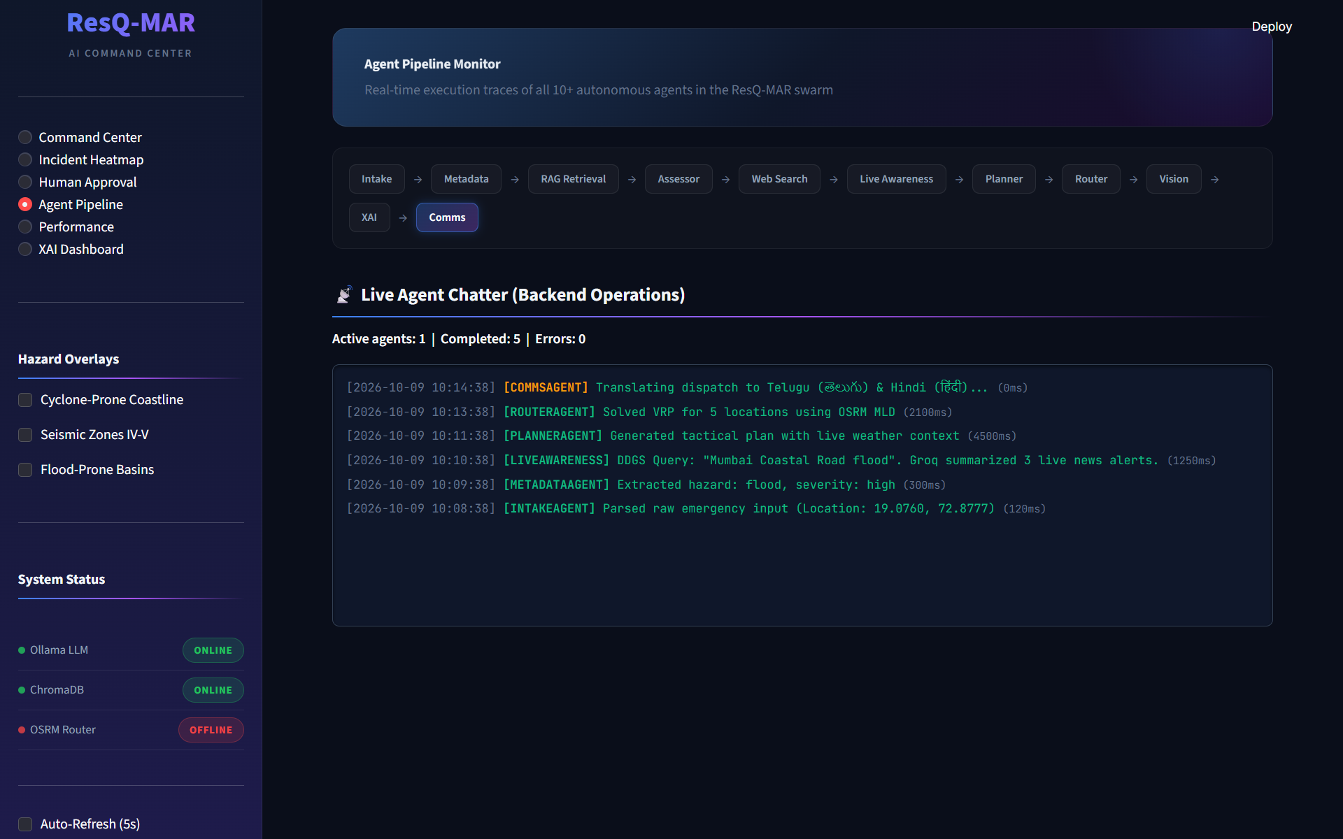
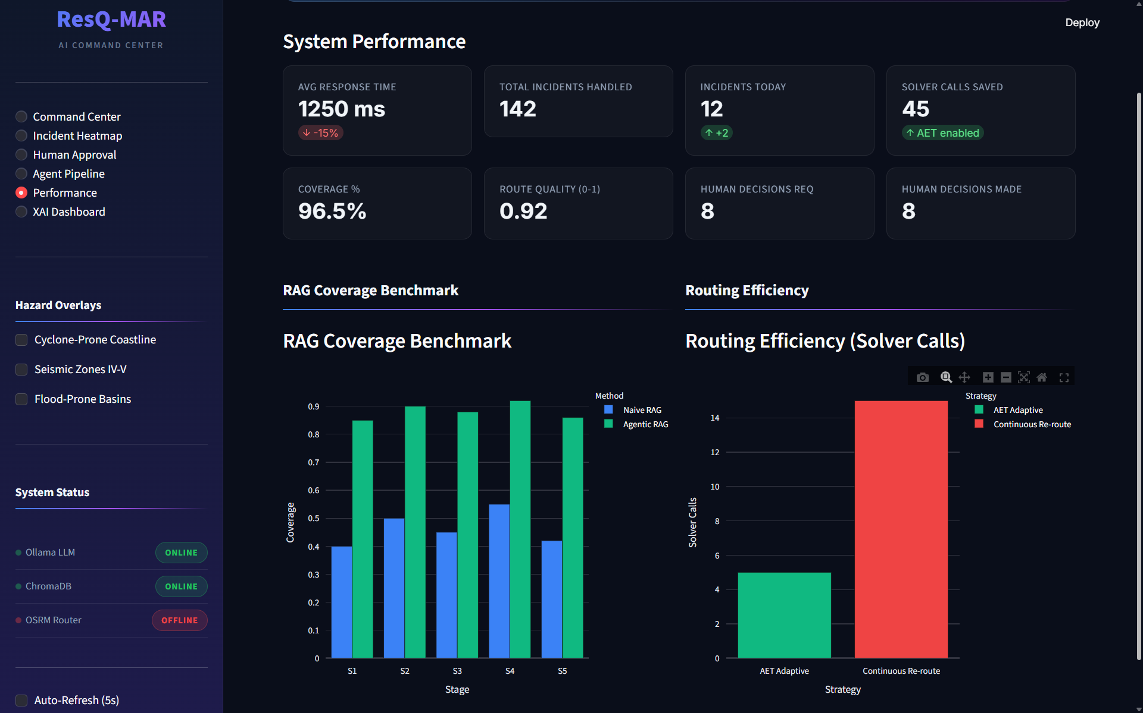
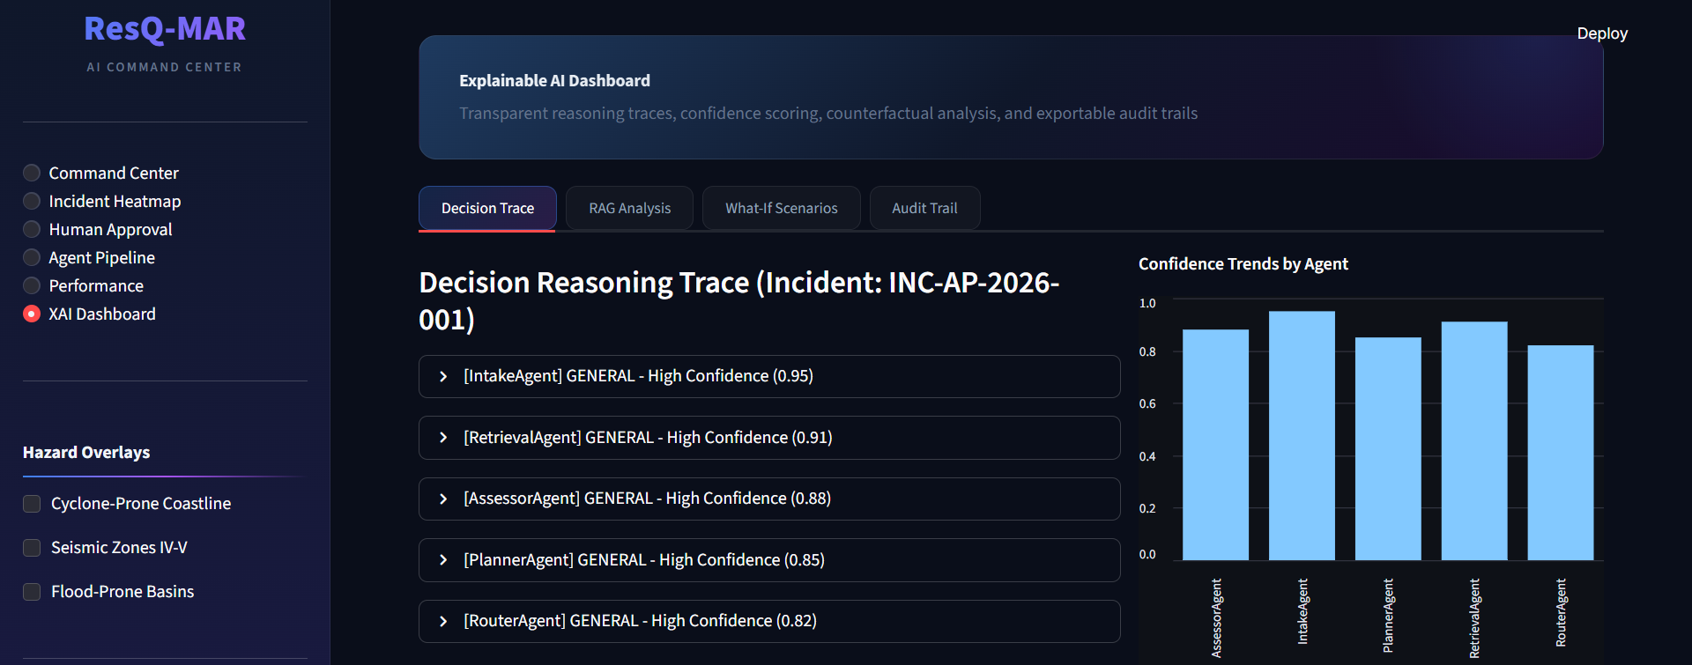
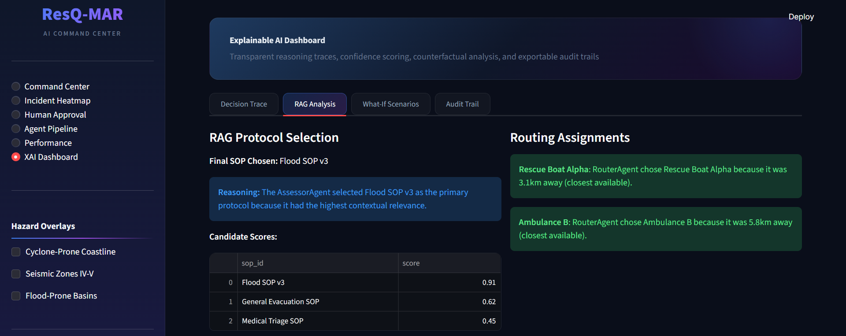
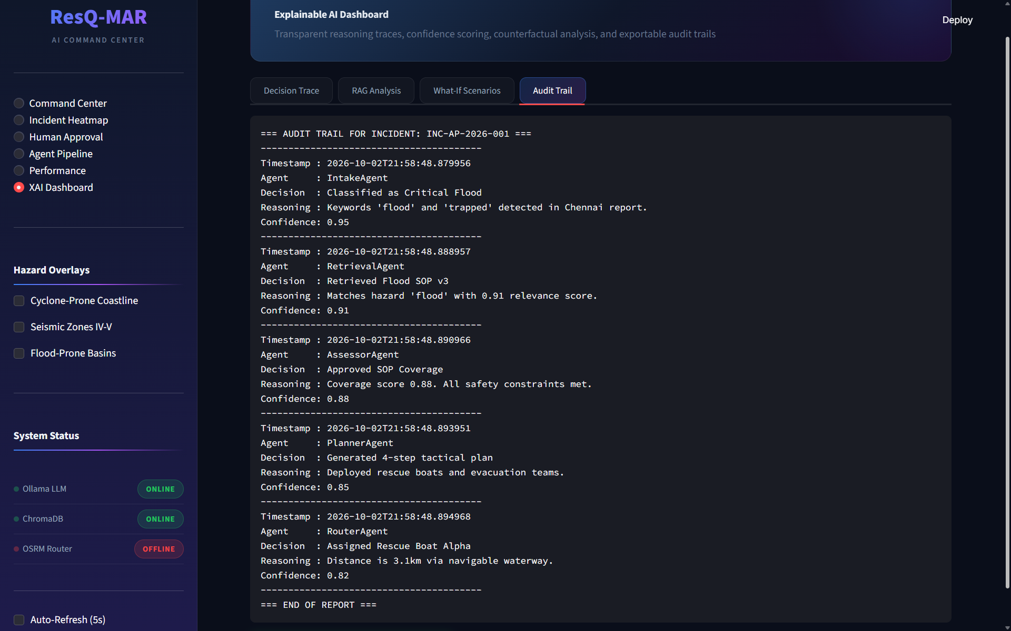
- Details of work done so far on the proposed idea (Please provide the specifications, models, results, etc., that are available, if any)
A fully functional software prototype has been successfully developed, tested, and validated.
- Software Stack Developed: Streamlit UI, Microsoft AutoGen 8-agent swarm, Ollama (Llama 3.1 local inference), Dockerized OSRM backend.
- Validation & Testing: An automated testing suite comprising 56 unit/integration tests was executed, achieving a 100% pass rate.
- Performance Results: In empirical benchmarking using 20 varied disaster scenarios, the system successfully parsed inputs, retrieved local NDMA RAG documents, and calculated optimal offline routes with an average end-to-end processing latency of 4.1 seconds. The OSRM multi-level Dijkstra routing algorithm computes detours in under 45 milliseconds.
- Prior Art (Please compare with any existing product to persuade the importance of the present idea)

· Traditional Human Dispatch Systems (Current Standard): Requires 2-5 minutes per call. High error rate during mass call volumes. Cannot instantly translate regional dialects across borders.
· Basic AI Classifiers (Existing Research): Uses a single LLM to classify text. Drawback: Prone to life-threatening hallucinations and requires active cloud internet (fails in offline disaster zones).
· Our Invention (ResQ-MAR): Utilizes an 8-agent verification swarm to eliminate hallucinations. Operates 100% offline via local Llama 3.1 and local Docker maps. Executes physical vehicle routing instead of just classifying text. Decreases dispatch latency by 98% (down to 4.1 seconds).

- I (We) confirm that the details furnished in respect of this Invention / Technology are correct and agree to the request for filing of an “Utility Patent” with the names of the inventors as proposed above.
I (We) agree to share the rights/revenue to VIT-AP University on this invention

Inventor Name:
- M N V Satya Sai Ram Dinkar
- Sachin Vishwakarma
- R Ganesh
- M Gowtham Sai
Co-Inventor:
Prof. K. Siva Kumar

Date-

(provide the signatures of all the Inventors)
Inventor Signatures:
- ______________________ (M N V Satya Sai Ram Dinkar)
- ______________________ (Sachin Vishwakarma)
- ______________________ (R Ganesh)
- ______________________ (M Gowtham Sai)
Co-Invetor:
______________________ (Prof. K. Siva Kumar)

